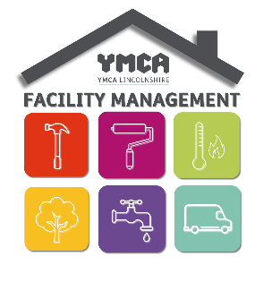
YMCA Lincolnshire Repair Categories
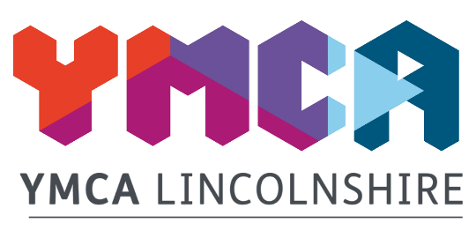
Emergency repairs to be completed within 24 hours of reporting or made safe if they full repair cannot be carried out.
- Any dangerous electrical fittings which cannot be isolated
- Any security issues which would leave one of our buildings insecure
- Water leak through a ceiling where the water cannot be isolated
- Total loss of electrics
- Total loss of heating where heaters cannot be provided (between October and March only)
- Total loss of water to the building
- Emergency works following a fire
- Drainage issues for the whole of the building
- Fire alarm cannot be reset
- Full loss of access control
- Inspect damp and mould complaints

The following repairs will be completed within 5 working days
- Renew toilet seat
- Replace light bulb
- Repair tap dripping
- Replace window restrictors
- Turnaround of a void room
- One radiator not working
- Unblock sink or toilet
- Ceiling light not working
- Remove mould
- Replace batteries on door guards
- Fire door not closing due to closer being faulty

All other repairs
All other repairs will be completed within a timescale of 20 working days

